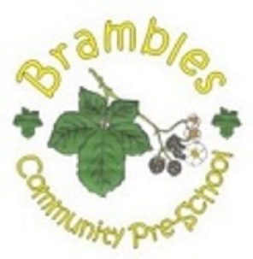
Brambles Home Learning Bags

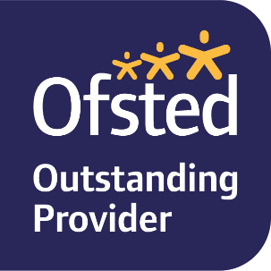
A childs language development begins long before they start school and is shaped by the people and places in their lives – their home learning environment. Our aim is to enrich the home learning environment by offering a selection of bags, covering such subjects as art & craft and science, for parents to borrow and use at home. The bags hang by our main door and can be borrowed from 1 day or up to a week. All we ask is that you sign them out and back in again and leave a photo/comment on Tapestry to show how you have used them.

