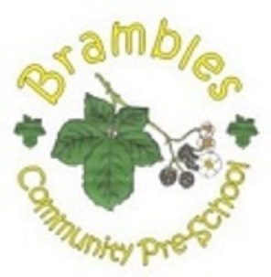

Moo music

Music is an essential part of a childs development, and they find the songs positive, uplifting, fun and educational, constantly learning while having fun. The interactive sessions help children to gain confidence and help develop their memory, language and coordination skills in an exciting, enjoyable and multi-sensory way. We have Moo Music sessions in the pre-school weekly, changing the day and session so that all children get to participate.

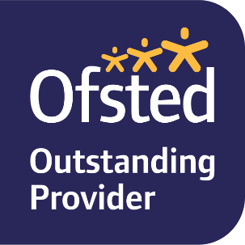
http://www.moo-music.co.uk/

