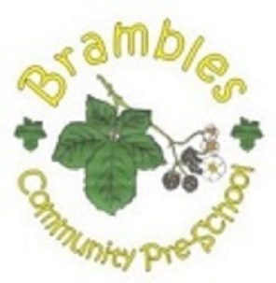
Brambles Narrative Therapy

Narrative Therapy is a well-structured, pre-written programme for teaching question words and narrative skills. The use of colour visual support to aid learning of the key elements and teach children how to move from the individual story elements onto producing their own narratives. For children aged 3-5 years we introduce the Narrative structure of “who” “where” “when” and “what happened”.

